US Domestic Flight Delay Drivers
CISC7204 Data Science and Data Visualization | Assignment 02 | Class K, Pair 14
LI Yingfang (mc661599) | LI Tianhao (mc663312)
October 2026

1. Project Overview and Research Question
An end-to-end analysis of 7,079,061 U.S. domestic flights in 2024. The region is the United States and the domain category is commercial air transportation. The project attributes delay minutes to the five causes published by the U.S. Bureau of Transportation Statistics (BTS, n.d.-a, n.d.-b), tests which observable factors matter most for delay length and severe-delay risk, and turns the evidence into static figures and an interactive Dash dashboard. Figure 1 summarises the cause split; Figure 2 (Section 3) shows the dashboard that will carry the argument.
Flight delay is a useful public-interest problem because the same average can hide very different experiences. A traveller mainly wants to know the chance of losing an afternoon; an airline or regulator needs to know where delay minutes originate. Our analysis therefore treats cause composition, typical delay, severe-delay risk and factor ranking as separate questions rather than reducing them to one headline number.
Research question: Which factors - distance, month, reporting carrier, origin airport and scheduled departure time - most strongly influence the length and frequency of U.S. domestic flight delays, and how can an interactive dashboard communicate these patterns clearly to a non-specialist?
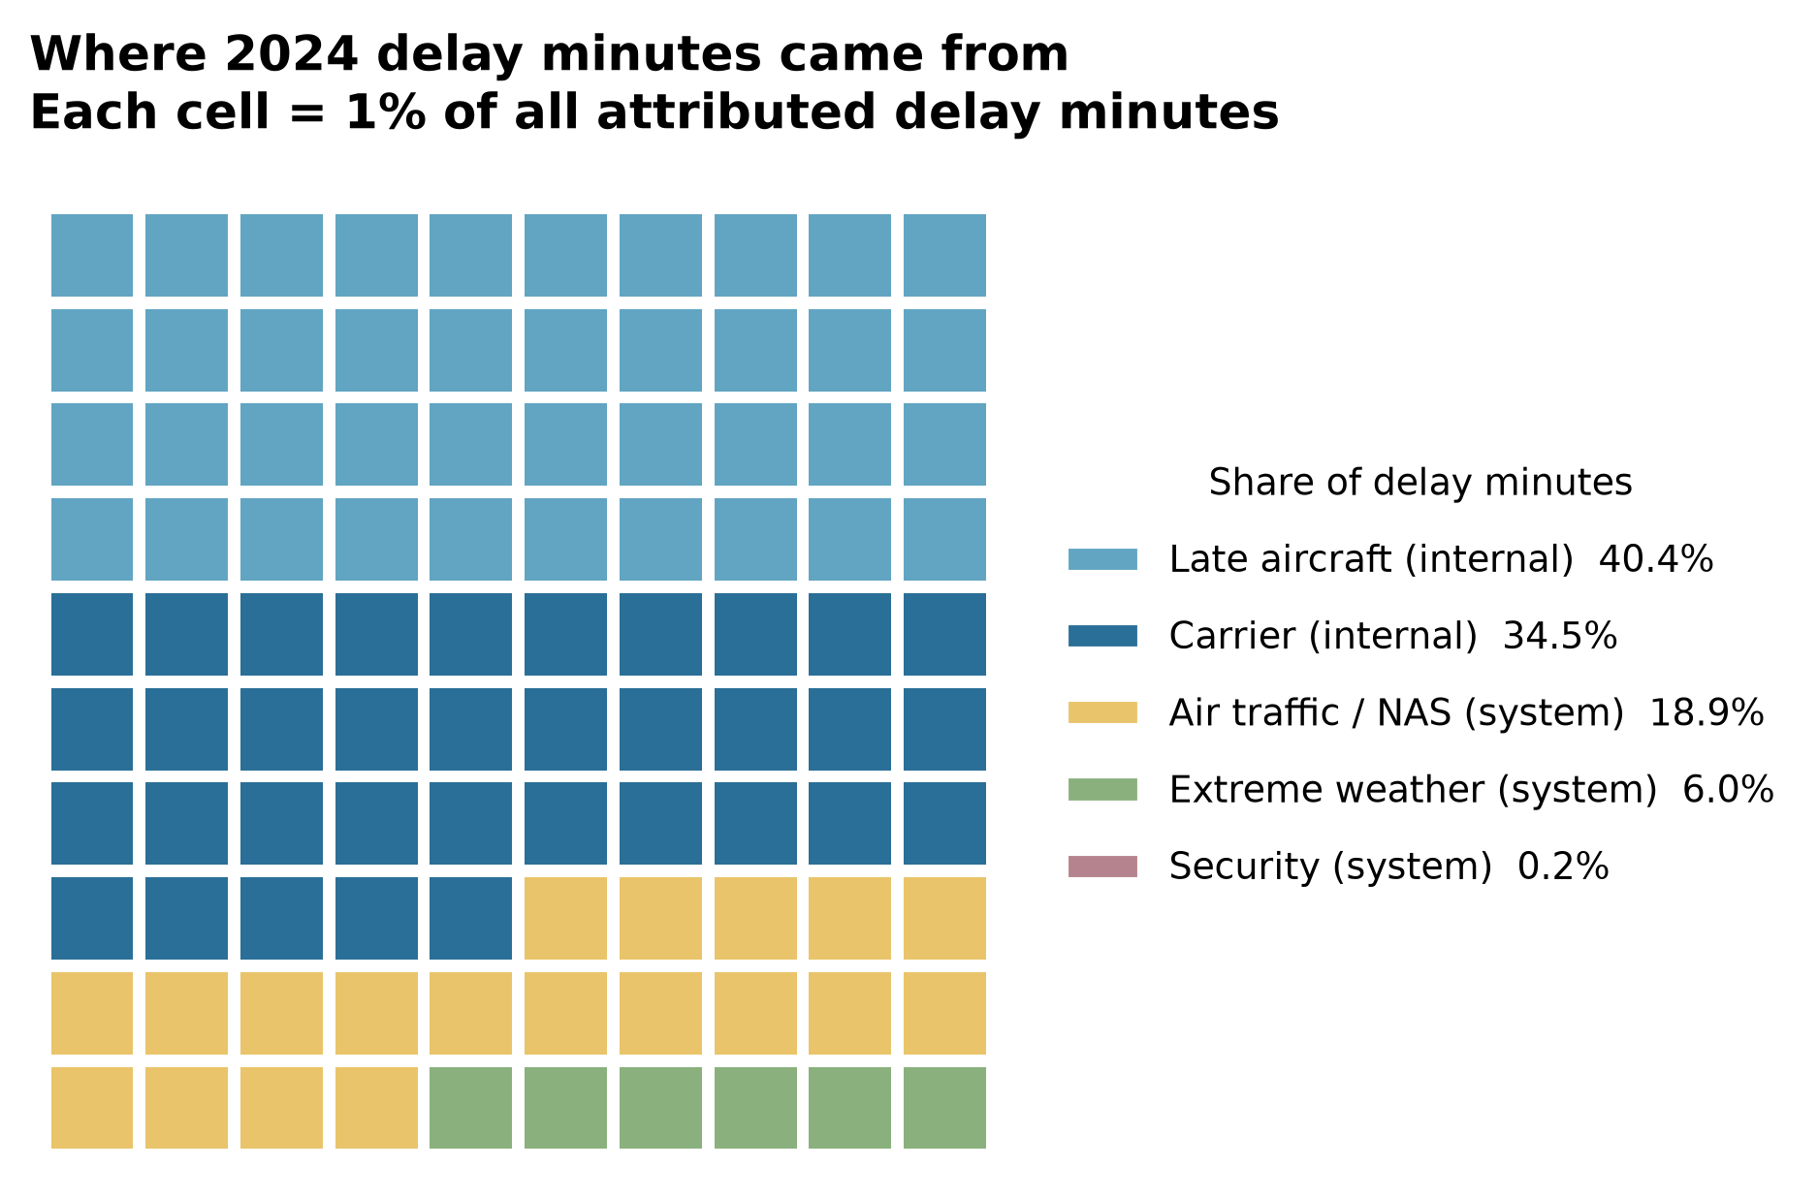
Fig. 1 Attribution of 2024 delay minutes: 75.0% airline-controlled, 25.0% system-imposed (each cell = 1%).

2. Project Purpose
Outcomes. The project connects to three course learning outcomes: selecting visual encodings that fit different data structures and questions; moving from exploratory description to an appropriately qualified statistical comparison; and designing an interactive communication product for a non-specialist audience. It also produces a portfolio-ready example of an end-to-end data project, from public-source acquisition to reproducible delivery.
Skills. We practise data engineering at scale, exploratory analysis, robust regression, quantile and logistic modelling, dashboard development with Dash, reproducibility testing and concise technical writing. Collaboration adds code review, issue tracking and presentation of decisions to a partner.
Knowledge. The work develops applied knowledge of the BTS delay-cause taxonomy, the 15-minute reporting threshold for cause minutes, the difference between mean and tail behaviour, incremental explanatory power, and the limits of observational models. It also reinforces when a bar chart, waffle, histogram, scatter, map or linked dashboard panel is the appropriate visual choice.

3. Project Tasks
We have completed a full pilot analysis of 7,079,061 reported domestic flights, including 6,965,247 completed flights with a known arrival delay. The final phase packages that work for assessment and public display. Table 1 summarises the workflow and the evidence produced at each stage.
Table 1. Analysis workflow and deliverables
Stage | What we do | Evidence or deliverable
Data and validation | Combine 12 monthly BTS files; clean types and missing values; verify completeness, duplicates and the cause-field threshold. | Executed Notebook 01; ingest summary; 126 MB analysis parquet generated from source files.
Attribution and EDA | Partition attributed delay minutes across carrier, late aircraft, air-traffic, weather and security; compare month, carrier, hour, distance and state. | Notebook 02; Figures 01-07; composition and state outputs.
Tail diagnosis | Compare mean, median, percentiles and severe-delay shares; test the proposed mean-versus-tail paradox; quantify concentration. | Notebook 03; Figures 08-12; tail and concentration results.
Factor ranking | Fit OLS with robust errors on a 600,000-flight sample; check p90 and 60-minute delay models on a 250,000-flight sample. | Notebook 04; model table; univariate and incremental R-squared rankings.
Dashboard and story | Finalise six linked panels, three filters and tooltips; produce the project README and final visual summary. | Dash application; dashboard screenshot; GitHub-ready README and final visual.
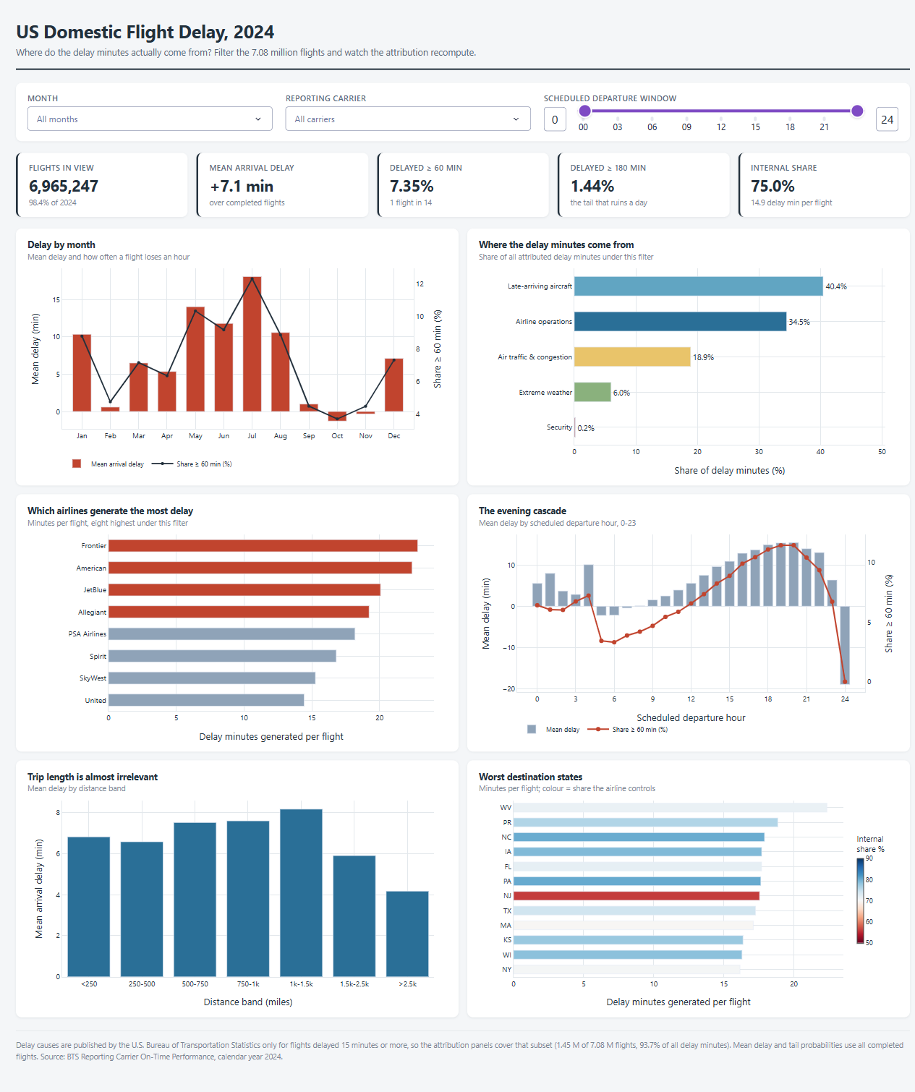
Fig. 2 The six-panel interactive Dash dashboard: linked charts with year, month and carrier filters.
Visualization rationale. The question has two halves, so the visuals are chosen per half. Which factors dominate is a part-to-whole question, so Figure 1 uses a unit waffle, where area encodes the share of delay minutes and the 75/25 split reads without a legend. Departure hour is ordered and cyclical, so its effect is drawn as a line cascade; a ranked bar would destroy the within-day pattern. Where the mean would hide the worst-hit flights, percentile bands and a Lorenz curve replace bar charts. The dashboard uses linked views and filters so a non-specialist can ask their own question.

4. Results at a Glance
Table 2. Summary measures for 2024
Measure | 2024 result
Reported domestic flights | 7,079,061
Completed flights with a known arrival delay | 6,965,247
Mean arrival delay | +7.1 min
Median arrival delay | -6.0 min
Delayed at least 60 min | 7.35%
Delayed at least 180 min | 1.44%
Delay minutes attributed to airline-controlled causes | 75.0%
Delay minutes attributed to system causes | 25.0%
Key findings.
1. Most delay minutes are airline-controlled. Carrier and late-aircraft causes account for 75.0% of attributable minutes. Late-arriving aircraft alone accounts for 40.4%, while air-traffic, weather and security together account for 25.0%.
2. Timing matters more than the carrier label. In the five-factor OLS comparison, departure hour contributes 41.1% of explained variance and month contributes 38.6%. Carrier follows at 17.1%, origin airport at 3.0% and distance at 0.3%; the five shares sum to 100.1% before rounding.
3. Distance is not the main driver. Once departure time, month and carrier are controlled, distance has almost no explanatory power. The apparent distance effect in the earlier Module 04 scatter plot was a confounding artefact.
4. The average is not the passenger experience. The median flight arrives 6 minutes early, while the mean is 7.1 minutes late and sits at the 73rd percentile. The worst 1% of flights generate 25.1% of all delay minutes.
5. A proposed mean-versus-tail paradox did not hold. Across months, mean delay and the share of flights delayed at least 60 minutes move together almost perfectly (r = 0.998). We report this null result and focus instead on the concentration and conditional patterns that remain supported.
The modelling is deliberately presented as ranking evidence, not a flight-level predictor. The five-factor OLS model reaches R-squared 0.029, and the 60-minute logistic model reaches AUC 0.679 on held-out flights. Those values are useful for comparing patterns and insufficient for promising a specific arrival time.

5. Data Sources
All datasets are public and reproducible; Table 3 lists each source with its role:
Table 3. Public data sources
Source | Use | Link
BTS Reporting Carrier On-Time Performance, 2024 | Primary flight-level data, 12 monthly files | transtats.bts.gov/PREZIP
BTS Airline On-Time Performance: Delay Cause | Cross-check of national cause shares | transtats.bts.gov/OT_Delay
OurAirports airports.csv | Coordinates and state reference for maps | davidmegginson.github.io/ourairports-data
The BTS files are U.S. federal government data and are publicly redistributable. The project uses every reported domestic flight in the 2024 files, not a convenience sample. Airport coordinates and state reference come from OurAirports (n.d.).
Reporting-threshold note: BTS publishes the five cause-minute fields only for flights delayed by at least 15 minutes. The analysis verifies this rule directly: 1,449,964 of the 1,449,966 flights at or above the threshold (57.5% of all delayed flights) have a complete cause breakdown (99.9999%). All cause-share statements are scoped to that attribution universe; counts, means and percentiles use all completed flights.

6. Repository and Reproducibility
The project is organised as a runnable repository:
Analysis/ (inside Project Proposal/ in the submitted folder)
|- README.md run instructions and project overview
|- requirements.txt pinned Python dependencies
|- run_all.py end-to-end rebuild: ingest, notebooks, figures
|- src/ common.py, 01_ingest.py, 05_proposal_figure.py, py2ipynb.py
|- notebooks/ 01_Data_Preparation, 02_Delay_Attribution_EDA,
| 03_Right_Tail_Paradox, 04_Statistical_Modelling
|- dashboard/ data_access.py + app.py (six-panel Dash)
|- figures/ 16 publication-ready PNG figures
|- outputs/ CSV and text summaries used in the write-up
`- data/ raw/ and processed/ (excluded from Git)
Raw and processed data are intentionally excluded from version control because they total hundreds of megabytes and are reproducible from the public sources.
Run the project (Python 3.14 recommended):
cd "Project Proposal/Analysis" && pip install -r requirements.txt
python run_all.py # rebuild data, run notebooks, regenerate figures
python run_all.py --skip-ingest # notebooks only, if processed parquet exists
python dashboard/app.py # launch dashboard at http://127.0.0.1:8050
run_all.py rebuilds the notebooks from their _source/*.py files and executes them in a fresh kernel, so no result depends on stale notebook state.

7. Method Summary
Data preparation: standardise 110 source fields, retain the analysis columns, convert to efficient types and validate counts, duplicates, missingness and the 15-minute threshold.
Descriptive attribution: group reported delay minutes into airline-controlled causes (carrier and late aircraft) and system causes (air traffic, weather and security).
Tail analysis: compare mean, median, percentiles and severe-delay shares; use a Lorenz curve to show how delay minutes concentrate in the worst flights.
Factor comparison: fit OLS on a 600,000-flight sample with HC1 robust errors; compare incremental R-squared contributions for hour, month, carrier, origin airport and distance.
Robustness: fit p90 quantile and 60-minute logistic models on a 250,000-flight subsample with a fixed seed.
Interaction: expose six linked charts and three filters in Dash; recompute metrics after each filter rather than displaying pre-rendered images. Chart design follows Cairo (2016): one colour scale per cause, labelled thresholds, and value labels on the marks a reader needs to quote.
The models are used to compare aggregate patterns. BTS cause minutes are a reported partition, not an independent causal experiment.

8. Criteria for Success
We will use the checklist in Table 4 as our completion rubric. It states the minimum standard and the evidence that will be checked; the final visual is the one-page synthesis, not a substitute for the reproducible analysis.
Table 4. Completion checklist
Success criterion | Evidence accepted
Scope and data validity | Counts reconcile across source files; duplicate rate is zero; the 1,449,964-flight attribution universe and 15-minute threshold are stated wherever cause shares appear.
Analytical answer | All five candidate factors are compared for mean and tail outcomes; at least three findings directly answer the research question and none is presented as causal without support.
Reproducibility | All four notebooks execute end to end from a clean environment; the README gives install and run commands; outputs regenerate from code and raw public data.
Dashboard usability | The Dash app exposes six linked panels and three filters; controls recompute values, tooltips explain measures, and a non-specialist can locate a carrier, month or hour without training.
Communication and integrity | Every chart has a title, readable labels and a one-line interpretation; the final visual states the core story and the limitations of one-year observational data.

9. Limitations
One year of data. The 2024 snapshot cannot distinguish a structural pattern from a one-year operational shock.
Cause minutes follow BTS attribution rules. Overlapping causes are assigned by BTS; the 75/25 split is not an independent causal decomposition.
The models rank, they do not predict. R-squared 0.029 and AUC 0.679 show that flight-level delay depends on events outside the five available factors.
No independent weather covariates. "System" means the category BTS reports, not a separately verified storm or air-traffic event.
Heavy models use documented samples. The OLS and tail models use fixed-seed samples so the workflow remains fast and reproducible; descriptive results use every completed flight.

10. Team and Collaboration
We divide ownership by analytical stage while keeping interpretation, review and final sign-off shared. Table 5 records the primary roles; either member can cover the other during an absence, and both members review the final proposal and submission package.
Table 5. Division of work and group roles
Member | Roles | Primary responsibilities
LI Yingfang mc661599 | Project Coordinator Progress Tracker | Schedules checkpoints; owns data preparation and quality checks; leads exploratory analysis and static figures; maintains the success checklist.
LI Tianhao mc663312 | Project Scribe Liaison | Records decisions and meeting notes; leads statistical modelling and dashboard development; manages forum liaison and submission logistics; prepares the final visual.
Ground rules
- Use one shared GitHub repository, a branch per task, descriptive commit messages, and review before merging; never merge code or figures that cannot be reproduced from the notebooks.
- Keep one source of truth for numbers: a quoted result must match a notebook output or a CSV in outputs/. The same rule applies to the proposal, README and dashboard.
- Hold a short weekly checkpoint on progress, blockers and next actions; target a response within 48 hours and record decisions in the project log.
- Freeze scope by consensus. If a change affects the research question, dashboard or submission date, discuss it before implementing and record the decision.
- Before submission, each member completes an independent read-through of the proposal and a functional check of the dashboard.

11. References
Bureau of Transportation Statistics. (n.d.-a). Airline on-time performance: Delay cause [Data set]. U.S. Department of Transportation. Retrieved October 21, 2026, from https://www.transtats.bts.gov/ot_delay/ot_delaycause1.asp
Bureau of Transportation Statistics. (n.d.-b). Reporting carrier on-time performance (1987–present) [Data set]. U.S. Department of Transportation. Retrieved October 21, 2026, from https://www.transtats.bts.gov/DatabaseInfo.asp?QO_VQ=EFI
Cairo, A. (2016). The truthful art: Data, charts, and maps for communication. New Riders.
OurAirports. (n.d.). Airports [Data set]. Retrieved October 21, 2026, from https://davidmegginson.github.io/ourairports-data/airports.csv

